TDD using JUnit5 and Mockito
1. JUnit_Basic Testing Exercises
Exercise 1: Setting Up Junit
Solution:
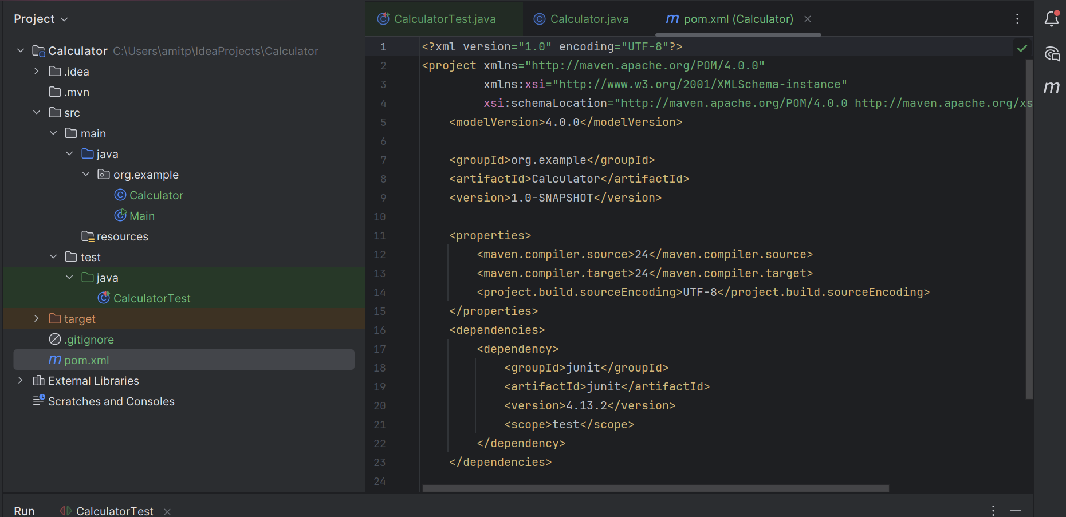
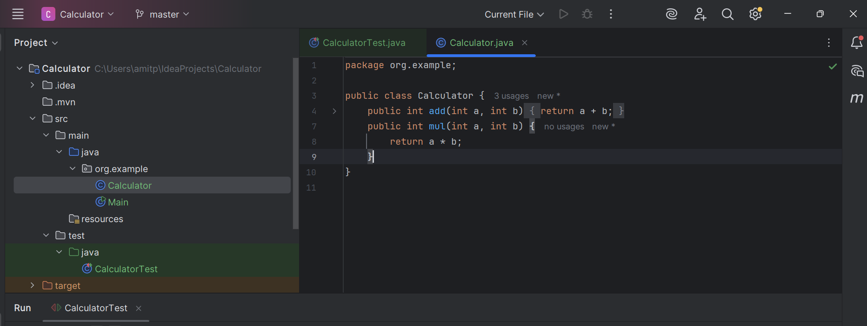
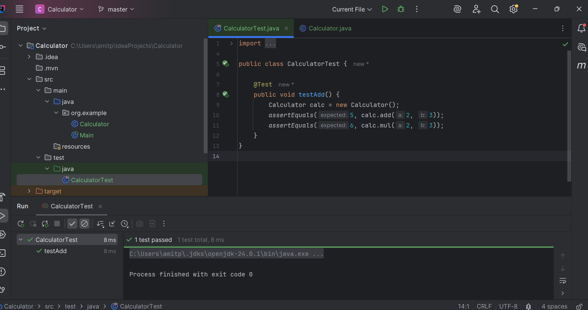
Exercise 3: Assertions in Junit
Solution:
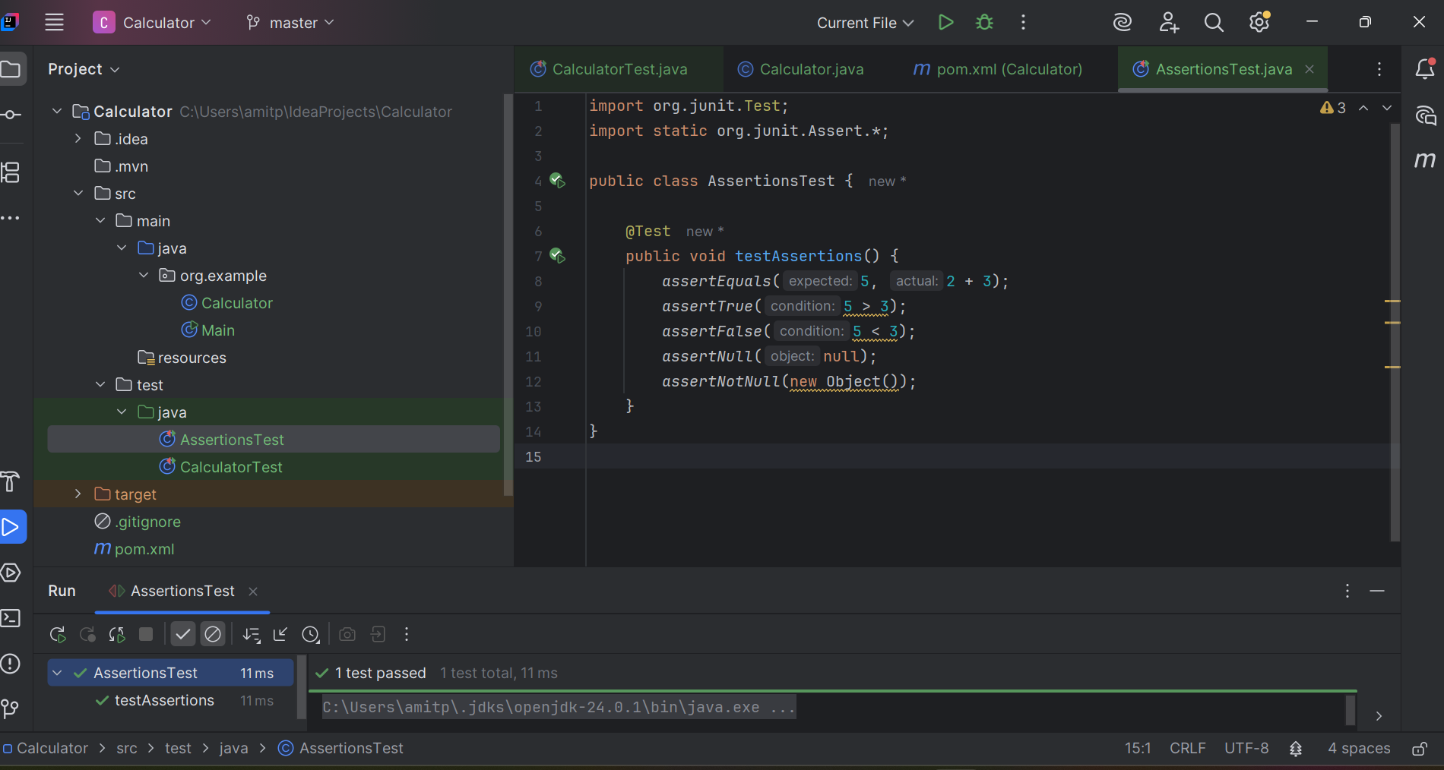

Exercise 4: Arrange-Act-Assert (AAA) Pattern, Test Fixtures, Setup and Teardown Methods in Junit
Solution:
